
STATISTICS & PROBABILITY
STATISTICS & PROBABILITY
Sonu Memon’s NoteBook
ABDUL HASEEB MEMON


Core Mathematical Concepts for ML, DL, Agentic AI & Robotics
------ Robotics & Agentic Ai Enthusiast ------

Introduction about Statistics and Probability
Statistics:
- Branch of Mathematics
- Father of Statistics Got Fried Achewal (1749),Karl Pearson Father of Modern Statistics
- Statistics is derived from:
  - Latin Status (Preference)
  - Italian Statista
  - German Statistics
Definition: Statistics is the Combination of different Tools, Techniques, and Methods used for Collection of Data, Presentation of Data, Analyzation of Data Interpretation of Data set is Called Statistics.
CONCEPT:
- Collect
DATASET
- Present
- Analysis
- Interpretation
Branch of Statistics:
- Descriptive Statistics: Branch of Statistics used for Collection, Presentation, Analysis and Summarization of Dataset. Dataset is Larger here.
- Inferential Statistics: Branch of Statistics used for making Predictions/inference about Population by using Sample Data. Dataset is Larger here.
Types of Statistics: (According to Applications)
- Bio Statistics: Application of Statistical tools and techniques on Bio/Medical data.
- Vital Statistics: Application of Statistical tools and techniques on Population data is Called Vital Statistics.
Basic Terms (Forms of Data):
- Population: Totality of Individuals / Observations (The Entire group you are Studying)
- Sample: Subset of Population
- Parameter: Numerical Value / Characteristics expressed about Population is Called Parameter. Eg: Average Height of all Students in a Country
- Statistics: Numerical Value / Characteristics expressed about Sample is Called Statistics. Eg: Average Height of sample of students from that Country.

Data: Data is Numerical Facts & Figures / Observations.
- Data Plural
- Datum Singular
Types of Data: (According to Source of Collection)
- Primary Data Source: Any Type of Data which has been collected originally and has not born through any statistical Procedure / Operations.
- Observations
  - Visual: Observations taken through Images
  - Listed: Observations taken through Lists formats
- Experiments: An activity with Possible Outcome.
  - General Experiment: Activity performed anywhere (no Restriction).
  - Lab Experiment: Activity Performed with in Room.
  - Field Experiment: Activity Performed in Field or at Large Area.
- Survey
  - Through Mobile: By Calling Someone to Grab Data.
  - Through Internet: By Providing Forms on Internet.
  - Through Courier/Post: By Letterheads & By using Courier Service.

- Secondary Data Source: Any Type of Data which has already born through any Statistical Procedure/Operations.
- Websites: Research Oriented Data (Web Scrapping)
- News Paper: General News related Data (Climate Conditions)
- Government Research: Chances of Flood (Remedies)

Variable: Variable is an Entity / Container that stores Values. The Value may change with respect to Object.
Types of Variable:
- Qualitative Variable / Categorical: Describes the Qualities / Category / Classification based Data (Non Numerical) (What Type of Data?)
- Nominal: Names of Categories. Eg: Pass & Fail, Yes & No, and Girls & Boys.
- Ordinal: Particular Sequence of Orders. Eg: Primary, Secondary, and Graduation.(Levels classified)
- Quantitative Variable / Numerical: Describes Numeric Data that can be measured or Counted (How Much Data?)
- Discrete: Fixed / Complete Integer (Finite/Infinite)
- Continuous: Measurement Based / Decimal Number

Constants: Those Values that may not change.
Presentation of Data: Process of Organizing and Displaying Data in clear & Understandable forms.
Eg: Tables, Graphs, Charts, and Diagrams etc.
Purpose: To make Data easy to read, Analyze & Interpret.
Types / Methods of Presentation of Data:
- Textual Method: Data present in the form of Text.
  - Text/Statement Method: Through Description Data can be presented. Eg: Out of 50 students, 30 passed in Math, 10 in Science, and the remaining 10 failed in both subjects.

  - Steam & Leaf Method: Splitting each number into a "stem" (leading digits) and "leaf" (last digit).
    - Rules:
- Sort the data first.
- Separate Leading digits & Last Digit.
- Present in Stem & Leaf Structure.
Eg: 43, 46, 47, 52, 54, and 59.
Stem | Leaf
4 | 3 6 7
5 | 2 4 9

- Graphical Method: Data Present in the form of Graphs/Charts.

  - Bar Chart / Graph: Pictorial / Graphical representation of Categorical Data.
    - Rules:
- Select the category of Data and arrange it on x-axis.
- Number of Frequency is on Y-axis.
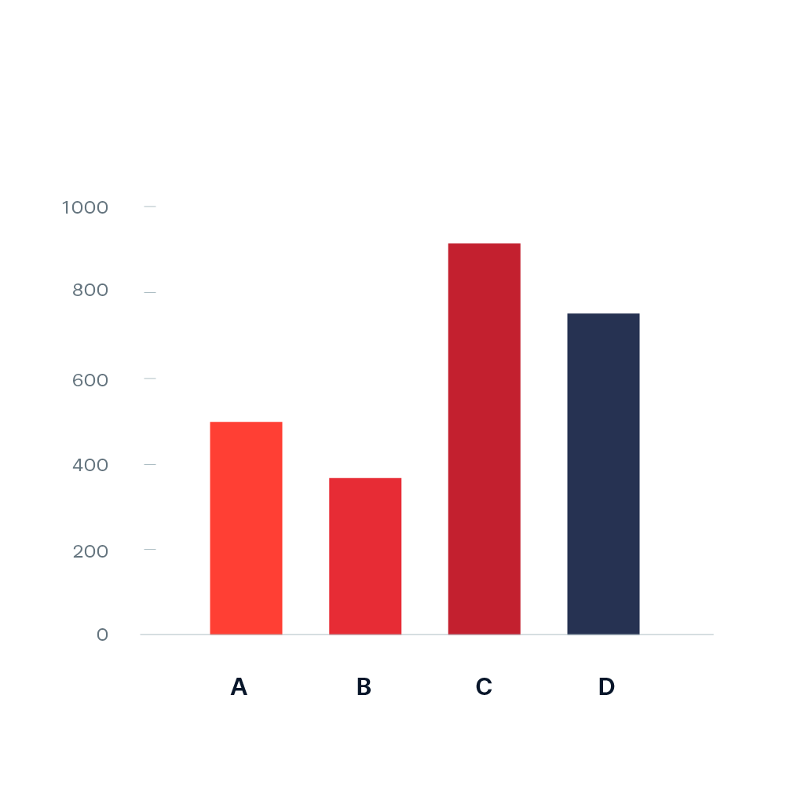

  - Histogram: it is also same as Bar Chart but there is no any space b/w each rectangle of graph that represents Data.

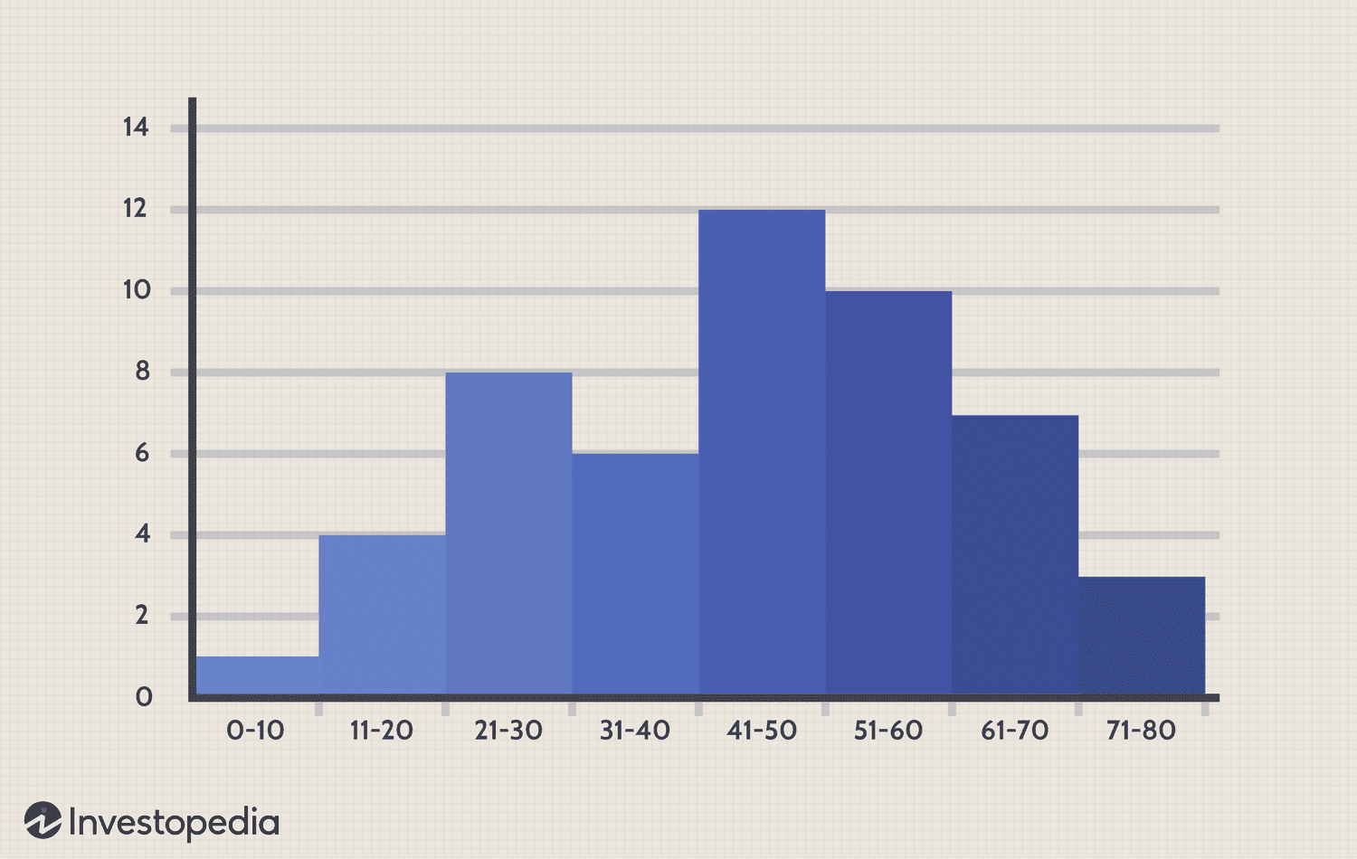

  - Historigram / Frequency Polygon Curve: Line Graph that shows the frequency of Dataset by plotting points (usually at midpoints of intervals) and joining them with Straight Line.

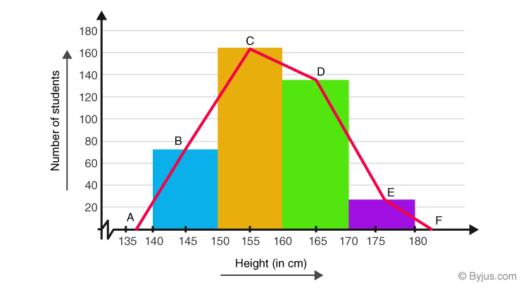

  - Pie Chart: It is a Circular Graph that is divided into sectors/slices where each slice represent the percentage of data.

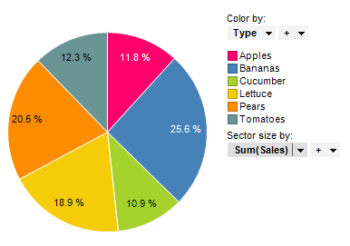

- Tabular Method: Data present in the form of Tables (Rows x Columns): (Categorical + Numerical Data)

  - Classification: Classification is the way/Method for presenting the data through different classes / Groups.
Eg:
- A Grade: 8 Students
- B Grade: 8 Students
- C Grade: 4 Students

  - Tabulation: Way / Method for representing data through different Rows & Columns (Table) along with Titles / Subtitles.

Eg:
Students Academia
Grade | No of Students
A Grade | 8
B Grade | 8
C Grade | 4

  - Frequency Distribution Table: It is way/ method for representing the data through Different classes or Groups along with its frequencies.

Eg: A, B, A, C, B, A, B, A, C, B, A, A, B, C, B, A, B, A, B, C
Grades Total: 20
Students Academia
Grade | No of Students
A Grade | 8
B Grade | 8
C Grade | 4
 | Total: 20
Rules: Frequency Distribution Table
- To sort the data (Rearrange the data in Ascending Order)
- Find the Range (R= maxValue - minValue)
- Find the no of Classes (k = 1 + 3.3 Log n)
- Find Class Intervals/ Width (R/k)
- Set the Class Limit (draw Table: first Column Class Limit followed by class intervals, Second Column Observations and Third Column Frequency)

Data: (100 Students' Marks)
45, 67, 89, 45, 23, 56, 78, 34, 90, 64, 59, 49, 37, 88, 29, 62, 33, 55, 67, 91, 71, 85, 92, 46, 73, 68, 84, 55, 63, 77, 54, 39, 27, 60, 87, 58, 69, 44, 61, 83, 76, 82, 93, 50, 53, 51, 30, 42, 81, 80, 35, 66, 79, 88, 74, 33, 57, 49, 65, 83, 41, 46, 70, 64, 31, 43, 38, 28, 66, 77, 67, 75, 59, 89, 52, 60, 44, 55, 62, 45, 47, 34, 58, 63, 68, 36, 90, 85, 78, 54, 40, 35, 32, 56, 48, 72, 53, 41, 65, 60

Rule 1: Arrange it in Ascending Order.
23, 27, 28, 29, 30, 31, 32, 33, 33, 34,34, 35, 35, 36, 37, 38, 39, 40, 41, 41,42, 43, 44, 44, 45, 45, 45, 46, 46, 47,48, 49, 49, 50, 51, 52, 53, 53, 54, 54,55, 55, 55, 56, 56, 57, 58, 58, 59, 59,60, 60, 60, 61, 62, 62, 63, 63, 64, 64,65, 65, 66, 66, 67, 67, 67, 68, 68, 69,70, 71, 72, 73, 74, 75, 76, 77, 77, 78,78, 79, 80, 81, 82, 83, 83, 84, 85, 85,87, 88, 88, 89, 89, 90, 90, 91, 92, 93

Rule 2: Find the Range
Range (R) = Rmax​−Rmin​= 93−23=70​

Rule 3: Find the no of classes
k=1+3.3log10​(n) where n=100, k=1+3.3log10​(100) =1+3.3×2=1+6.6=7.6 Round off: 8
k=8

Rule 4: Find the class Interval/ class Width
Class width=R/k​=70/8=8.75=9​

Rule 5: Set the class Limits & fill Frequencies in Distribution Table

Class Limits | (Observations) | Frequency
23 – 31 | 23, 27, 28, 29, 30, 31 | 6
32 – 40 | 32, 33, 33, 34, 34, 35, 35, 36, 37, 38, 39, 40 | 12
41 – 49 | 41, 41, 42, 43, 44, 44, 45, 45, 45, 46, 46, 47, 48, 49, 49 | 15
50 – 58 | 50, 51, 52, 53, 53, 54, 54, 55, 55, 55, 56, 56, 57, 58, 58 | 15
59 – 67 | 59, 59, 60, 60, 60, 61, 62, 62, 63, 63, 64, 64, 65, 65, 66, 66, 67, 67, 67 | 19
68 – 76 | 68, 68, 69, 70, 71, 72, 73, 74, 75, 76 | 10
77 – 85 | 77, 77, 78, 78, 79, 80, 81, 82, 83, 83, 84, 85, 85 | 13
86 – 94 | 87, 88, 88, 89, 89, 90, 90, 91, 92, 93 | 10
Total Frequency |  | 100

Measure of Central Tendency / Central Location

Statistical value that identifies the Center & Typical Value of dataset.
Purpose: To summarize large data sets with a single representative value.

- Mean/Simple Mean/Average/Arithmetic Mean: It is the Sum of all Observations/ values divided by Total no of Observations
Types of Mean:
- Population Mean: Mean of whole Data
  - Formula: μ= ∑X​ / N
- μ = Population mean
- ∑X = Sum of all values in the population
- N = Total number of values in the population

Eg: Population data: 10, 20, 30, 40, 50
μ= (10+20+30+40+50)/5=30

- Sample Mean: Mean of selected Data from Population
  - Formula: xˉ= ∑x​ / n
    - xˉ = Sample mean
    - ∑x = Sum of all sample values
    - 𝑛 = Number of values in the sample
Eg: Sample data: 15, 20, 25, 30
xˉ = (15+20+25+30)/4​=22.5

- Median: Median is any middle or Central value in the dataset which divides the dataset into two equal parts. (Median position of Actual data)
Rules:
- Rearrange the data
- Check for Even or odd
- Select the Formula According to even & Odd
- Put Values & Solve The Median

- Odd: md=(n+1)/2
Eg: 14, 20, 35, 17, 19, 22, 26
- 14, 17, 19, 20, 22, 26,35
- Odd= md=(n+1)/2
- md=(7+1)/2 = 4
- 4th Position: 20(median)
- 14, 17, 19, 20, 22, 26,35

- Even: md= n / 2
Eg: 14, 20, 35, 17, 18, 22
- 14, 17, 19, 20, 22, 35
- even= md=(n)/2
- md=(6)/2 = 3
- 3rd Position (from left & right): x=19(median)
- 14, 17, 18, x, 20, 22,35

- Mode: The Word “Mode” is derived from the French Word “Modus” which means fashions. The most frequently replaced value of an observation in the dataset is considered as Mode. (Numerical + Categorical Data).
Rules:
- List the data values & Rearrange them Carefully
- Count the frequency of each value.
- Identify the value(s) with the highest frequency.
  - If one value has the highest frequency → Unimodal (that’s the mode).
  - If two values tie for highest frequency → Bimodal.
  - If more than two values tie → Multimodal/Polymodal.
  - If all values occur equally → No mode.
Eg: Data: Categorical = Students’ Grade
Students’ Grade: A,A,F,B,C,E,F,A,F,C,B,F
Rearrange Grade: A, A, A, B, B, C, C, E, F, F, F, F
Mode: F (Unimodal)

Eg: Data: Numerical = Students’ Marks
Students’ Grade: 4, 15,24,4,13,8,19,24
Rearrange Grade: 4,4,8,13,15,19,24,24
Mode: 4,24 (Bimodal).

- Quantiles: Quantiles are any numbers which divides the dataset into equal parts.
The main purpose of Quantiles is to manage larger dataset.

Types of Quartiles:
  - Quartile: Any three Values Q1, Q2, Q3 divides the dataset into 4 equal parts.
Formula: For Odd
Q1= (n+1) /4
Q2= (2n+1) /4
Q3= (3n+1) /4

Formula: For Even
Q1= (n) /4
Q2= (2n) /4
Q3= (3n) /4

  - Decile: Decile are any 9 values which divides the dataset into 10 equal parts.
Formula: For Odd
D1= (n+1) /10
D2= (2n+1) /10
D3= (3n+1) /10
D9= (9n+1)/10
Formula: For Even
D1= (n) /10
D2= (2n) /10
D3= (3n) /10
D9= (9n)/10
  - Percentile: are any 99 values which divides the dataset into 100 equal parts.
Formula: For Odd
P1= (n+1) /100
P2= (2n+1) /100
P3= (3n+1) /100
P99= (99n+1)/100
Formula: For Even
D1= (n) /100
D2= (2n) /100
D3= (3n) /100
D9= (99n)/100

Measure of Dispersion / Spreadness / Variations / Disperse:
- Range: Range is basically find when we take a difference of two Values (highest – lower Value).
Formula: R_{max} – R_{min}
Data: 14,20,27,39,53,64,71,9
Rearrange Data: 9,14,20,27,39,53,64,71
Range=71-9=62

- Inter Quartile Range: Difference of two Quartile.
Formula: IQR = Q₃ – Q₁
Data: 14,20,27,39,53,64,71,9
Rearrange Data: 9,14,20,27,39,53,64,71
IQR= Q3 – Q1
Q3=3n/4 = 3(8)/4=6^{th Position} == 53
Q1=n/4 = (8)/4=2^{nd Position} == 14
IQR=53 - 14=39

- Quartile Deviation: Quartile Deviation is also called as Semi Inter Quartile Range (IQR) and defined as the half of interquartile Range. OR Alternate method for Range but it is used when the data has large set of Outlier.
Formula: Q.D= IQR/2
Data: 14,20,27,39,53,64,71,9
Rearrange Data: 9,14,20,27,39,53,64,71
IQR= Q3 – Q1
Q3=3n/4=3(8)/4=6^{th Position} == 53
Q1=n/4=(8)/4=2^{nd Position} == 14
IQR=53-14=39
D.Q=39/2=19.5

- Mean Deviation: Mean Deviation is the arithmetic mean of deviations. All the deviations are counted as positive. And All the deviations are calculated from either Mean or Median.
Formula: M.D= (∑ |x- xˉ|)/n
Data: 8, 12,10,15,20
Mean: xˉ= ∑xi/n = 65/5=13

| x | x − x̄ | |x − x̄| |
|-------|------------|--------------|
| 8 | 8 − 13 = -5 | 5 |
| 12 | 12 − 13 = -1 | 1 |
| 10 | 10 − 13 = -3 | 3 |
| 15 | 15 − 13 = 2 | 2 |
| 20 | 20 − 13 = 7 | 7 |
| Σ | | 18 |

M.D= (∑ |x- xˉ|)/n = 18/5 =3.6
- Variance: Variance is define as the arithmetic mean squared deviation. All deviations are calculated other from the mean and from the median.

For Sample Data:
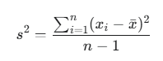
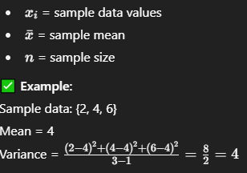

For Population Data:
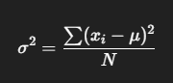

Xi​ = each data value
μ = population mean
N = total population size
Population data: {2, 4, 6}
Mean = 4
Variance = ((2−4)²+(4−4)²+(6−4)²)/3=(4+0+4)/3=2.67
- Standard Deviation: It tells us how much the data values deviate (spread out) from the mean on average. It’s simply the square root of variance.

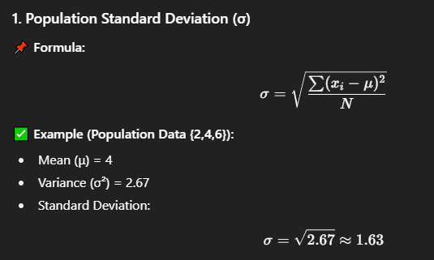
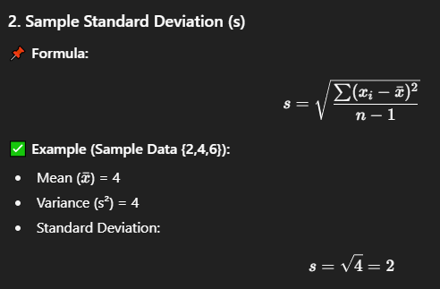

Sampling
Sampling is the process of selecting a subset of individuals, items, or observations from a larger population to study and make conclusions about the whole population. OR
Sampling is the way or Procedure used for population or samples used for Population.
Purpose:
- Save time & cost (studying entire population is impractical).
- Get reliable estimates of population characteristics.
- Make data collection manageable

Target Population:
The entire group of people, objects, or events that a researcher wants to study and draw conclusions about. OR Target Population is the type of population from which the samples will be selected.
- It is the bigger universe you are interested in.
- Sampling is done from this population.
Example:
If you are studying the eating habits of university students in Pakistan:
- Target Population = All university students in Pakistan.
Sampling Unit:
The single element or group of elements considered for selection during sampling.
It’s the basic unit from which a sample is drawn.
Example (continuing above):
- If you sample individual students → the sampling unit is a student.
- If you first divide by universities and then sample within them → the sampling unit may be a university.
Term | Meaning | Example
Target Population | The whole group you want to study | All university students in Pakistan
Sampling Unit | The individual element (or group) you actually choose for sample | One student / one university / one class, depending on method

- Sampling Techniques:
  - Random Sampling / Probability Sampling (Unbiased): Every element in the population has a known, non-zero chance of being selected.
- Simple Random sampling → Every item has equal chance.
Eg: Picking names from a hat.
- Systematic Sampling → Select every k-th element from a list.
Eg: Every 10th student from a roll call.
- Stratified Sampling → Divide population into groups (strata) and randomly sample within each.
Eg: Sampling students from each grade level.
- Cluster Sampling → Divide population into clusters (often geographic), randomly choose clusters, then study all within.
Eg: Select 3 cities out of 10 and survey all households inside them.
- Multi-stage Sampling → Combination of methods applied step by step.
Eg: First choose provinces → then districts → then households.
  - Non – Random Sampling / Non-Probability Sampling (Biased): Selection is based on convenience, judgment, or voluntary choice → not every element has a known chance of being selected
- Convenience Sampling → Easy to access samples.
Eg: Asking friends for survey.
- Judgment / Purposive Sampling → Researcher selects “most relevant” samples.
Eg: Interviewing only expert doctors for a study.
- Quota Sampling → Ensure specific proportions (e.g., gender, age) without randomization.
Eg: 50 males + 50 females, chosen by researcher’s ease.
- Snowball Sampling → Existing participants recruit new ones.
Eg: Drug user study where one refers another.
- Voluntary Sampling → People self-select to participate.
Eg: Online poll on a website.

CONCEPT MAP
Target Population
↓
Sampling Frame
(The actual list or database of the population)
↓
Sampling Unit
(Smallest element/group chosen for sampling)
↓
Sample
(Final set of units selected for study)

1. Simple Random Sampling (SRS)
Definition: Every member of the population has an equal chance of being selected.
How: Use lottery method, random number generator, etc.
Example: Picking 50 students randomly from a university of 1000.
2. Systematic Sampling
Definition: Select every k-th element from a list after a random start. (Rule + Regulations)
How: Population size (N) ÷ Sample size (n) = k (interval).
Example: From 1000 employees, pick every 10th person after choosing a random start point.
3. Cluster Sampling
Definition: Divide population into clusters (groups), randomly select some clusters, and study all members within them. (Based on Research Questions)
How: Useful when population is spread out geographically.
- Select Specific sample of population.
- Sampling unit different.
- Less time taking.
- Specific statement research.
Example: Out of 100 schools in a city, randomly choose 10 schools and survey all students in those schools.
4. Stratified Sampling
Definition: Divide population into strata (subgroups) based on characteristics, then take random samples from each stratum proportionally.
How: Ensures representation of all key groups.
Example: In a company, divide employees by departments (IT, HR, Finance) and randomly select proportional samples from each.
Quick Comparison Table
Sampling Type | Method | Key Idea | Example
Simple Random | Pure random pick | Equal chance for all | Randomly pick 50 students
Systematic | Every k-th unit | Regular interval | Every 10th employee
Cluster | Random groups | Study whole groups | Select 10 schools, all students
Stratified | Random within groups | Ensure subgroup representation | Pick from each department
Non – Random Sampling / Non-Probability Sampling (Biased): Selection is based on convenience, judgment, or voluntary choice → not every element has a known chance of being selected. (There is no any Uncertainty)
- Judgement: Purely based on judgement where accessibility required.
- Convenience: It is something where we are accessible to that particular findings.
- Quota: Particular Predetermined percentage or Limit.
- Snowball: It is something refer by something like surveys. Or based on particular Reference.

Introduction to Probability:
Probability is a measure of uncertainty or the likelihood of occurrence of an event.
It is a numerical value that expresses how likely an event is to occur.
Purpose: The purpose of probability is to quantify uncertainty and support decision-making where outcomes are not certain.
Three Ways to take the Probability:
- Decimal: 0 ----0.5---- 1
- Fraction: 0 ----1/2---- 1
- Percentage: 0% ----50%---- 100%
Probability of Event: P (E):
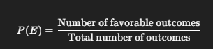
Formula: no of favorable Outcome / Total no of Outcome
Eg:
If you toss a coin:
- Total outcomes = 2 → {Head, Tail}
- Event (E): Getting a Head
- P(E)=1/2​
- Probability of getting a head = 0.5 or 50%

History of Probability:
Year / Period | Scientist / Mathematician | Contribution
1550s | Gerolamo Cardano (Italy) | Wrote “Book on Games of Chance” (published posthumously in 1663). First to use mathematical methods to analyze gambling; introduced ideas of favorable and total outcomes.
1654 | Blaise Pascal & Pierre de Fermat (France) | Their famous correspondence on gambling problems laid the foundation of modern probability theory. Defined the concept of expected value.
1657 | Christiaan Huygens (Netherlands) | Published “De Ratiociniis in Ludo Aleae” (“On Reasoning in Games of Chance”) first printed book on probability. He introduced rules for calculating probabilities.
1713 | Jakob Bernoulli (Switzerland) | Published “Ars Conjectandi” (“The Art of Conjecturing”). Introduced Law of Large Numbers, showing that experimental results approach theoretical probability as trials increase.
1812 | Pierre-Simon Laplace (France) | Published “Théorie Analytique des Probabilités”. Developed Bayesian interpretation, normal distribution, and methods for scientific and statistical applications.
1837–1850s | Siméon-Denis Poisson (France) | Introduced Poisson distribution, applied probability to real-world events like accidents and random occurrences.
1900–1930s | Andrey Kolmogorov (Russia) | Formulated axiomatic foundation of probability in “Foundations of the Theory of Probability” (1933). His work gave probability a rigorous mathematical structure.
Mid-1900s onward | Various scientists (e.g., Fisher, Neyman, Pearson) | Developed statistical inference, sampling theory, and modern probability applications in science, economics, and AI.
Importance of Probability:
Field / Area | Use of Probability | Purpose / Example
Weather Forecasting | Used to predict the likelihood of events like rain, storms, or temperature changes. | Example: “There is a 70% chance of rain tomorrow.”
Medicine & Genetics | Helps in diagnosing diseases and predicting the chances of inheriting genetic disorders. | Example: Probability of a child inheriting a certain disease.
Financial Markets | Used to estimate profit, loss, and risk in stock trading and investments. | Example: Calculating the probability of stock prices rising or falling.
Games & Gambling | Determines the chances of winning or losing in games of chance. | Example: Probability of getting heads when tossing a coin is 0.5.
Business Models | Helps businesses in demand forecasting, decision-making, and risk management. | Example: Probability of a new product being successful.
Insurance Sector | Used to assess the risk of accidents, illness, or property loss to set premiums. | Example: Probability of car accidents helps in setting insurance rates.
​

PROBABILITY
It is a Measure of likelihood or Chances that an event will occur.
Probability (Mathematically): Quantification of that Event.
Chance (Daily | Common Language): Qualification of that Event.
Eg: Person A is Rich clarifies that Person A is Rich Qualify (Chance to be a Rich or Not)
Probability is to show Quantification for that Possibility. Person A is 2 Lacks actually a Richer in prices or Amount.
Event: All Activities or Possible Cases Categorized from Sample Space. OR It is Cases for Outcome to happen.
Chance: Any Activity that Participates on the basis of an Event.
Probability: Prediction of Particular Event to be happen.
EXAMPLE (ROLLING A DICE)
Chance of 5 to be happen Qualify that 5 has a possibility to happen but if I am going to say how much the possibility of 5 to be happen Quantification.
Sample Space for Rolling a Dice is: D = {1,2,3,4,5,6}
Than, I Select a Cases to get an Event: Possible Cases = {Even, Odd}
Sample SpaceEvent/CasesOutcomePrediction / Probability (the exact Chance of that outcome to be happen).
Solve: Mathematically Probability P(E) = Event (Cases==Odd)/ Sample Space.
Now Putting Values P(E) = 3/6 = 0.5 or ½ this is for ODD but if I have to Calculate for just 5 then, 1/6 Why? Because 5 exist once on a particular Dice and there are possible 6 outcomes in a sample space and there is a Condition to be happen than the probability of 5 is 1/6 comes only once between 6 rolls. (WRONG)
Because 5 exists only once in the sample space of a dice, and there are 6 possible outcomes, so the probability of getting 5 is 1/6 from that Sample Space. (CORRECT)

TYPES OF AN EVENTS:
Fair Events:
Fair Events has equally likely Events to Occur like in Rolling of a Dice Example we have 3 Even and 3 odd so all over the probability is 0.5 and here both side the Sample Space is Balanced. In other Example Tossing a Coin there are also a Fair Events Either Head or Tail has probability is 0.5.
Mutually Exclusive Events:
Occurrence of 1st Event Excludes the occurrence of Another or 2nd. OR None of two Events occur at same time as Event of a Even excludes the Event of an Odd as none of two Events can be occur at same time for Mutually Exclusive Events. OR getting a 2 and a 5 in the same single roll is impossible.
Independent Events:
Two Events are independent if the happening of one Event does not affect the probability of another. OR The Result of first doesn’t affect the another.
Eg: Rolling a dice two times first roll does not affect second roll.
Simple Event:
An event with only one outcome.
Eg: Getting a 4 when you roll a dice.
Compound Event:
An event with more than one outcome.
Eg: Getting an even number {2,4,6}.
Sure (Certain) Event:
An event that is guaranteed to happen.
Eg: Getting a number between 1 and 6 on a dice roll.
Impossible Event:
An event that cannot happen.
Eg: Getting a 7 on a dice roll.
Non-Mutually Exclusive Events:
Events that can happen at the same time.
Eg: Event A = Prime {2,3,5}, Event B = Odd {1,3,5}; Number 3 satisfies both.
Dependent Events:
Events where the outcome of one affects the other.
Eg: Not common in dice (because dice rolls are independent),
but if you remove outcomes from a box of dice faces, then it becomes dependent.
Complementary Events:
Two events whose probabilities add up to 1.
Eg: A = getting even; A’ = getting not even (odd).
Exhaustive Events:
Events covering all possible outcomes.
Eg: {1,2,3,4,5,6} is an exhaustive set for a dice roll.
Equally Likely Events:
Events with the same chance of occurring.
Eg: Getting any number from 1 to 6 on a fair dice.
Unequally Likely Events:
Events that do not have the same chance of occurring.
Eg: Not in fair dice; but if dice is biased, 6 may occur more often.
Random Event:
Any event whose outcome cannot be predicted with certainty.
Eg: The result of a dice roll is always a random event.

TYPES OF PROBABILITY
- Simple Probability: Any One Event has a Chance to Occur. Eg: 6 in a Dice = 1/6
- Joint Probability: Any Two Events that happen together at the same Time. Eg: A & B (both Event will Occur at Same Time). Suppose Rolling a Dice has 3 Cases one is for Even , second is for Odd and the third one is for Prime as if I say:
Prime={2,3,5}
Even={2,4,6}
Odd={1,3,5}
As There are total 3 events now we Calculate here the Chance of Prime and Even to Occur at same time (2(occur in both at same time So Common),odd(3,5),Even(4,6) but its outcome)
So, the joint probability of Prime and Even occurring together is:
P (Prime ∩ Even) = Number of common outcomes / Total outcomes = 1 / 6
Only 2 is common in Prime and Even, so the probability of both outcomes are happening at the same time is 1/6.
- Conditional Probability: Any Event that is already happened and that is dependent on specific Event to be happen.
Eg: Probability that the Patient Survives, given that he has been taken the Medicine.
(Now Survive & Medicine are two different Events as One(Survive) can be found by another Event(Medicine) on the basis of who has taken the Medicine and they will Survive).
FOR ROLLING A DICE
Restricted sample space = Even numbers = {2, 4, 6} → total 3 outcomes
Favorable outcome for Prime in this space = {2} → 1 outcome
So here the sample space is restricted and perused as a 3 means Even already happened now the common 2 is happening only once So the probability will be 1/3
- Classical (Theoretical) Probability: Probability based on logical reasoning and equally likely outcomes.
Eg: P (getting a 4) = 1/6 on a fair dice.
- Empirical (Experimental) Probability: Probability based on repeated trials and observed outcomes.
Eg: If you roll a dice 60 times and 6 appears 12 times,
P (6) = 12/60 = 1/5.
- Subjective Probability: Probability based on personal belief or judgment.
Eg: “I feel like 6 might come this time” personal guess.
- Marginal Probability: Probability of a single event without considering others.
Eg: P(Odd) = {1,3,5} = 3/6 = 1/2.
- Compound Probability: Probability of two or more events occurring in sequence.
Eg: Rolling a 3 first and then 6: P(3 and 6) = 1/6 × 1/6 = 1/36.
- Complementary Probability: Probability of an event not happening.
Eg: P (not 5) = 5/6 on a dice.
- Independent Probability: Probability where one event does not affect the other.
Eg: Two dice rolls: P (4 on first AND 2 on second) = 1/6 × 1/6 = 1/36.
- Dependent Probability: Probability where one event affects the other.
Eg: Dice normally have no dependent events, but if you remove a card showing dice numbers, then later probabilities change.
- Mutually Exclusive Probability: Events that cannot happen at the same time.
Eg: Getting 3 and 6 together in one roll = not possible.
- Non-Mutually Exclusive Probability: Events that can occur at the same time.
Eg: Prime {2,3,5} and Odd {1,3,5}: Number 3 is common → can occur in both.

BAYES THEOREM
Bayes Theorem is a formula that tells us how to update the probability of an event when new information about another event is given.
20
C
B2
20
V
B1
30
V
10
C

B1 & B2 are Entities. And V= Vanilla, C= Chocolate these are Objects. Here What is the purpose of Byes Theorem If we have a conditional Probability So Let’s Discuss:
As If I want to find the Vanilla on the basis of given probability of B1 then it will be Okay but what if I used to say that If I am going to evaluate a B1 on the basis of Vanilla than here I find the probability of an Entity and how can be its possible to take a probability of an Entity and that Entity is dependent or bound on the inner object enclosed with in it. So, that’s why we have approach of Bayes Theorem.
FORMULA:
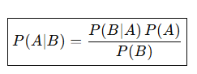

COMBINATORICS
It is the branch of Mathematics that Studies Counting, Arranging, & Selecting an object in a Systematic Way.
It tells How Many Ways, In What Arrangements, How many Possible Selections.
Purpose:
- To Calculate total Possible Outcomes
- Understand the Probability
- To Optimized Choices
- Model Real World Decision Problems
- Reduce time by avoiding long Manual Counting
Uses/ Methods:
- Permutation: Arrangements / Arranging / Ordering
Here Order matters (i,j) ≠ (j,i)
Formula:
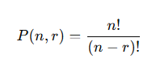

- Combination: Selections / Choosing
Here Order does not matter (i,j) = (j,i)
Formula:
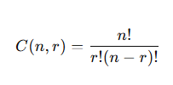

- Counting principle: Counting Simply according to Tasks
When tasks occur in sequence, total ways are found by multiplying choices.
Formula: If task-1 = m ways and task-2 = n ways, then total ways = m*n.
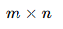

- Factorials: (Product Notation) Product of all Numbers Downward.
Formula:
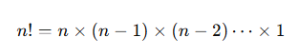

PROBABILITY DISTRIBUTIONS
A probability distribution tells us how the probabilities are spread over all possible outcomes of a random variable.
Purpose:
- What values a random variable can take
- And how likely each value is
Types:
- PMF: (Probability Mass Function) When We Mark a probabilities of Discrete Values on a graph is Called PMF.
Formula:
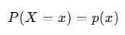
- PDF: (Probability Density/Distribution Function) When We have certain range in graph and between certain range if we have to find the probability than simply we take area of that range and this technique performs in PDF.
Formula:
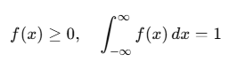
- CDF: (Cumulative Distribution Function) CDF tells the probability that a random variable is less than or equal to a certain value. It always increase never decrease. Its graph is Saturated after crossing 1.
Formula:
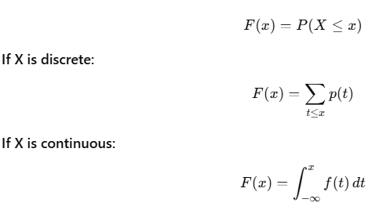
Concept | Shape | Type | Meaning
PMF | Bars | Discrete | P (X = x)
PDF | Smooth curve | Continuous | Density, not direct probability
CDF | Steps or smooth increasing | Both | P(X ≤ x)

Z-SCORE
It tells us how much a Value is distant (Standard deviation) from a Mean. It also tells How much we are Confident about the specific Chance b/w duration (range) that gives us number of S.D units.
Purpose:
- For outlier Detection
- Comparing Values from different Scales
- Standardization
- Probability Calculation
- To predict Confidence Level of where the probability lie at
Formula:
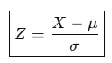

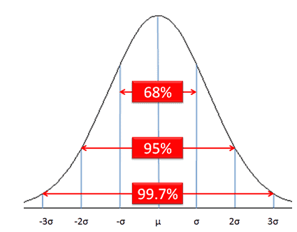

Confidence/Confidence Interval:
Degree of Certainty that Calculated interval actually contains true population parameters or not. OR how much your surety level or you are sure about that your estimation is near / closer to population value.

Eg: Mean Height = 170cm (168cm – 172cm) So, Surety/ Confidence Interval is 95%.

Certain Ranges:
- (µ - σ) to (µ + σ) 68.2%
- (µ - 2σ) to (µ + 2σ) 95%
- (µ - 3σ) to (µ + 3σ) 99.7%

